Triforce%
By Stompee
(fastest route as of 5/7/2021)
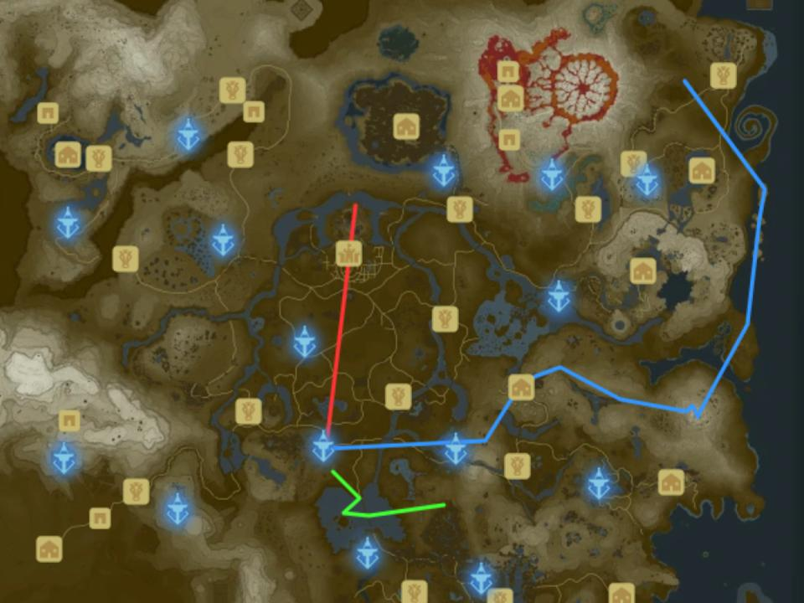
*Click for resources*
(red>blue>green)

Plateau
Stasis: 12 peppers, 3 shrooms, 5 arrows, bow, shield, axe
Cryonis: Try not to eat
Magnesis: Optional forest land; Land at bog, grab fire+ice arrows(fire arrows are optional but rely on you getting a cycle later on so they are recommended for new runners), get rng crates
Bombs: Slab launch/box walk to tower and activate
Glider: Knights bow, grab arrow after tree launch

Castle
any% banana crate btb
fh N to slab and grab chest containing naydra scale
Jump N off cliffs and break rock, open chest, get scale
Wb N and warp to tower

Impa
Fh/bf super SW towards temple of time
btb to kakariko
pray to statue and get heart
Grab apples and mushrooms under impa’s house
Talk to impa twice

Spring of Wisdom
Fh left of E
Grab fairies, carrots, and radish
Cryo block Fh E land on hills
Aim right of E and Fh slight turn left sl
Do a second Fh E if needed
Land on arch above moblin and perform a btb to Mt. Lanayru
Wb to naydra
Watch cutscene, drop scale near gate, complete shrine

Spring of Power
Slight turn right N
Land on ice, NE late circle place or complete horizontal wb to talus plat
Btb to Ankel island
Grab radish(es)
Wb N to boko
Btb to spring land near gate
Drop scale
Get north skew on shrine , tos skip , ragdoll cancel!!!

Spring of Courage
Warp to bomb, wb SE towards lake
Land on bridge and sit by fire
Wb to farosh, shoot farosh while in flight
Grab scale
Wb up to the head of the bridge
Bf vr super to hill with durians
Wb NE to spring
Land near gate, Drop scale
Timing ends when the glass on the final shrine is broken

Changelog
V1.5 - Grabs gp tower before bombs shrine, Gets fairies after talking to impa, Introduces a new btb from Lanayru Promenade to Mt. Lanayru, Revamped btb to ankle island, warps to bomb shrine and skips SOR cutscene by using a fire to pass time.

